Dataset and Statistical Analysis
- Source Data: 50 clean speech utterances extracted from the LibraSpeech corpus.
- Non-Linear Chaotic Noise: 10 non-linear noises applied. Nine represent continuous chaotic systems (Ikeda, Logistic, Skew Tent, Hénon, Chen, Mackey-Glass, Lorenz, Duffing, Rössler). One acts as a discrete stochastic counterexample (Bernoulli).
- Testing Scale: 5 Signal-to-Noise Ratio (SNR) levels evaluated (-10, -5, 0, 5, 10 dB). Processing 50 files against 10 noises across 5 volumes generated 2,500 unique audio combinations.

Absolute Topological Mapping
Evaluating metric behavior at maximum degradation (-10 dB SNR) exposes the limitations of linear acoustic scoring.
- The PESQ Blind Spot: The industry-standard metric grades heavily corrupted Bernoulli noise at 4.41, nearly identical to the 4.64 clean speech baseline. Linear algorithms cannot detect discrete binary jumps.
- CSI Gradient Separation: The Chaos Signature Index maps structural corruption accurately. It distributes the continuous chaotic systems along a distinct numerical gradient, ranging from 0.165 to 0.344.
- Anomaly Rejection: Natural speech established a stable baseline at 0.360. Enforcing a biological constraint penalty on extreme permutation entropy successfully suppressed false recurrence clusters. This forced the impossible phase-space geometry of the Bernoulli noise out to 0.461, preventing a false positive.
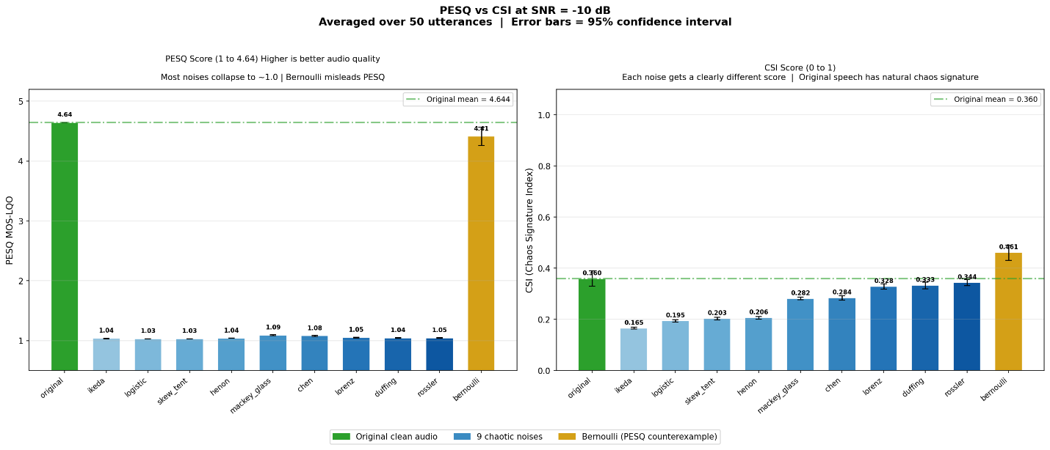

Metric Stability and Recovery
Translating absolute scores into a relative distance metric ($Δ$CSI) isolates geometric recovery as interference fades.
- Stochastic Recovery: As the SNR improves toward +10 dB, the $Δ$CSI trace for Bernoulli noise drops sharply toward the 0.0 perfect preservation target. The metric correctly recognizes that lower-volume discrete drops cause less phase-space fragmentation.
- Topological Persistence: Continuous chaotic systems leave a permanent structural footprint. The blue $Δ$CSI trace remains essentially flat near 0.12 across a 15 dB sweep (-10 to +5 dB).
- Sensitivity Over Amplitude: Quiet continuous chaos permanently alters the geometric trajectory of the vocal tract. Volume-based metrics miss this underlying damage entirely. CSI operates as a hyper-sensitive structural detector, mapping topological corruption regardless of acoustic loudness.

